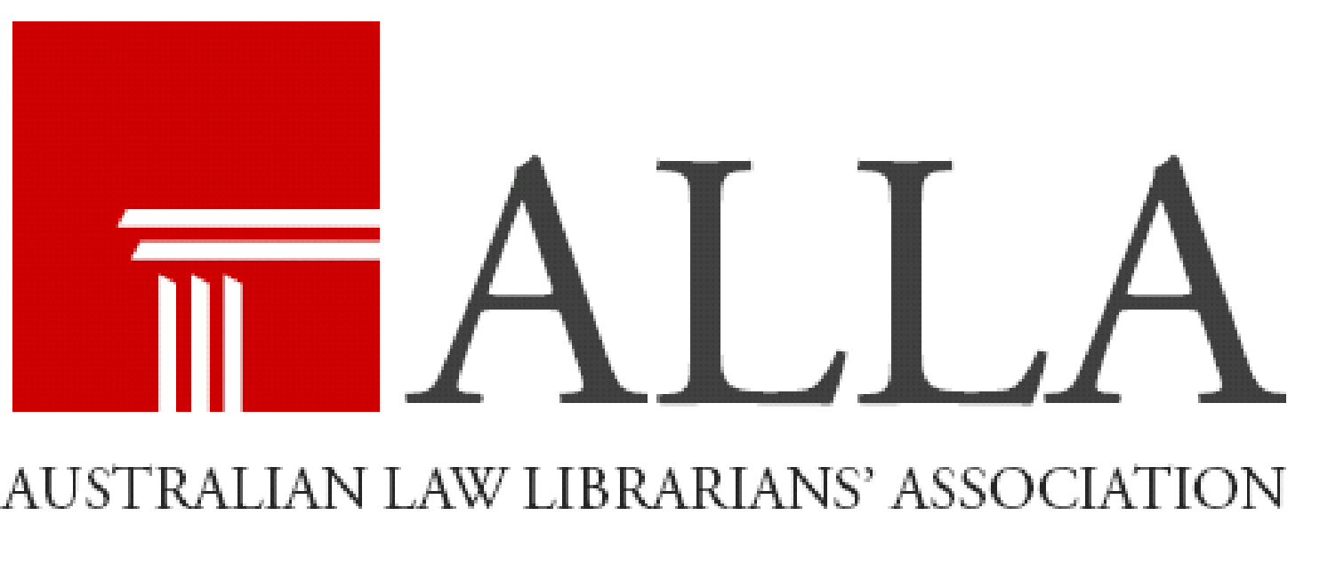
ALLA (NSW Division) Nomination Form
December 2020
Position nominated for:
Name of nominee:
Organisation:
Position:
Address:
Telephone:
Email:
Acceptance of nomination:
Nominated by:
Nominated by:

Please email the completed form (CC the nominee and both nominators) to:
Melissa Mills
Hall & Wilcox
p: (02) 8267 3730
e: austlawlib.nsw@gmail.com

